Lesson 7: Case Study ; CAN on RPi HAT (Assignment 7)

My setup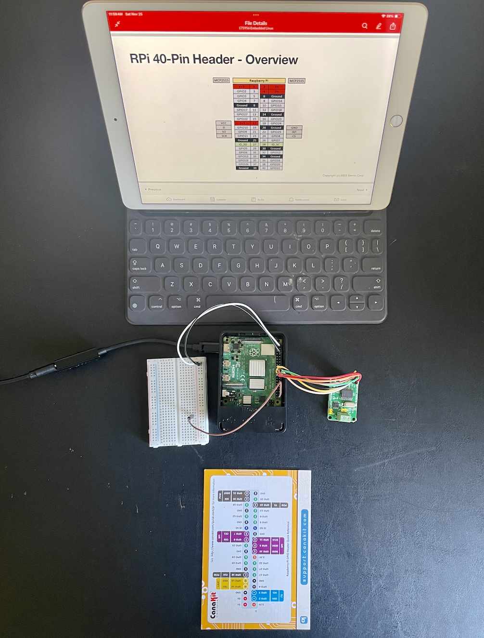

Command - sudo apt install wiringpi

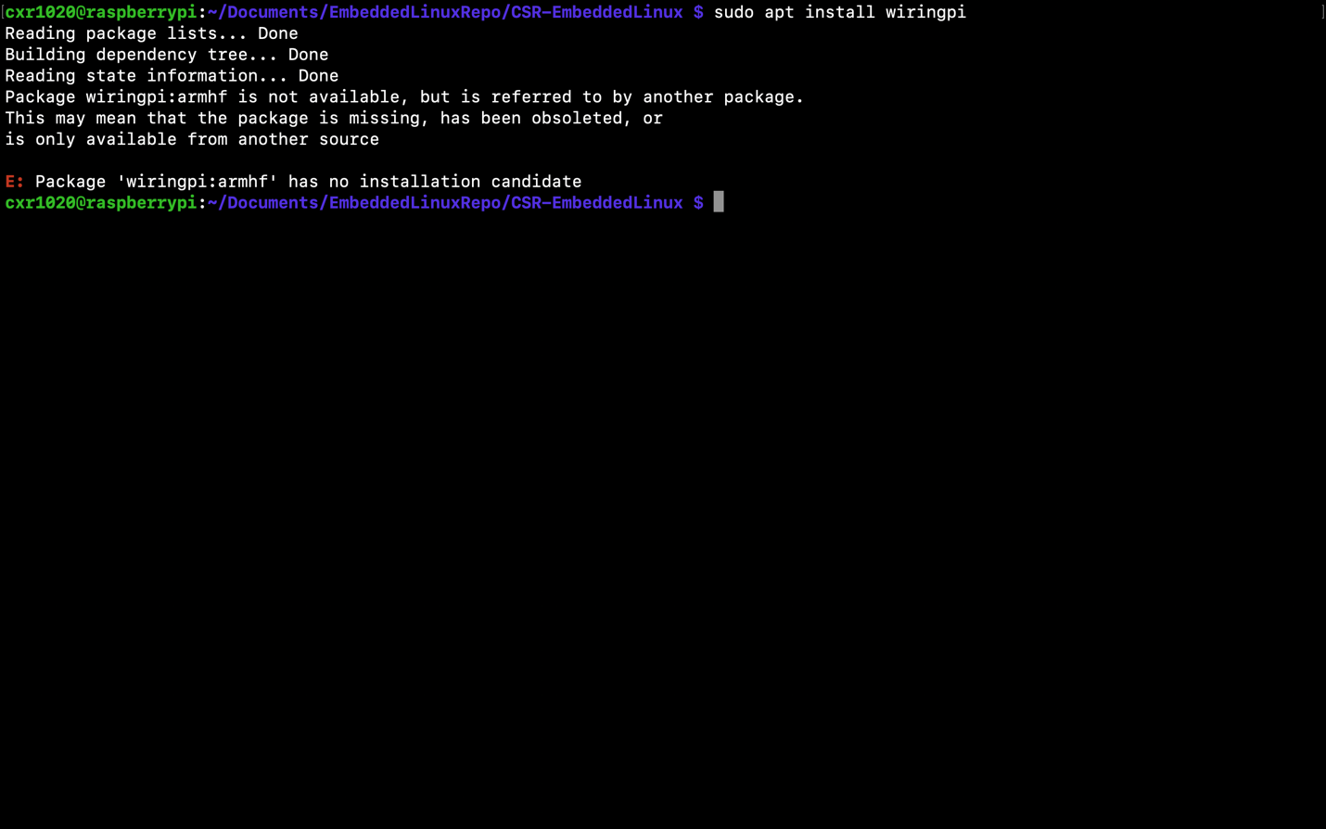

Command - git clone [git@github.com:WiringPi/WiriingPi](mailto:git@github.com:WiringPi/WiriingPi)

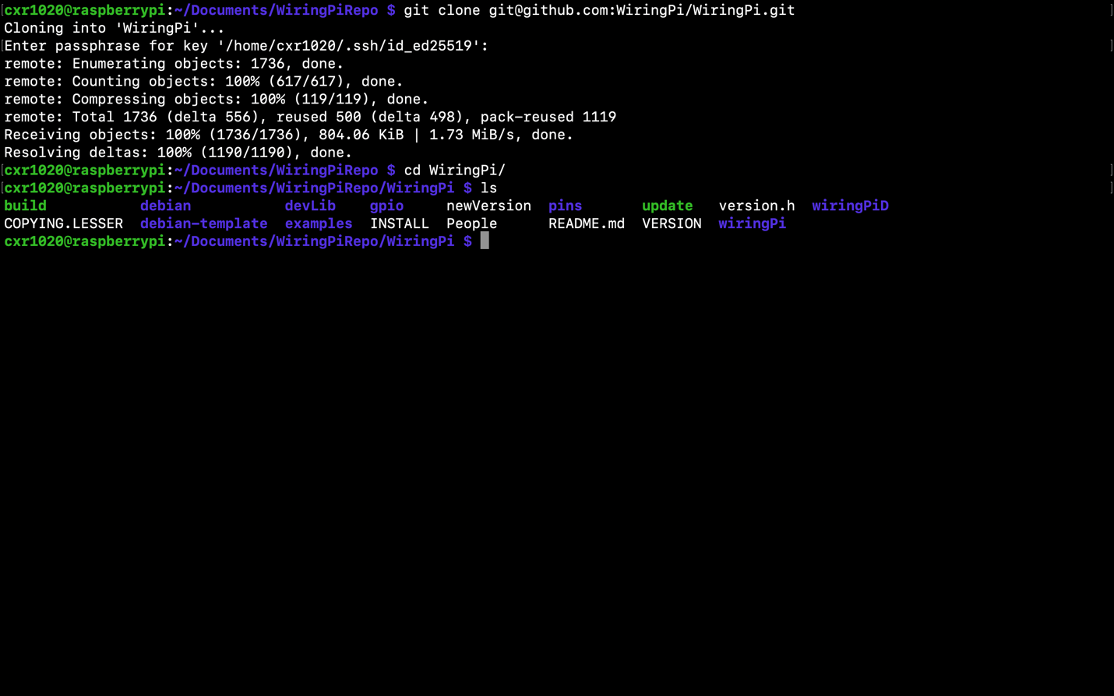

SourceCode - build_sh (wiringpi)

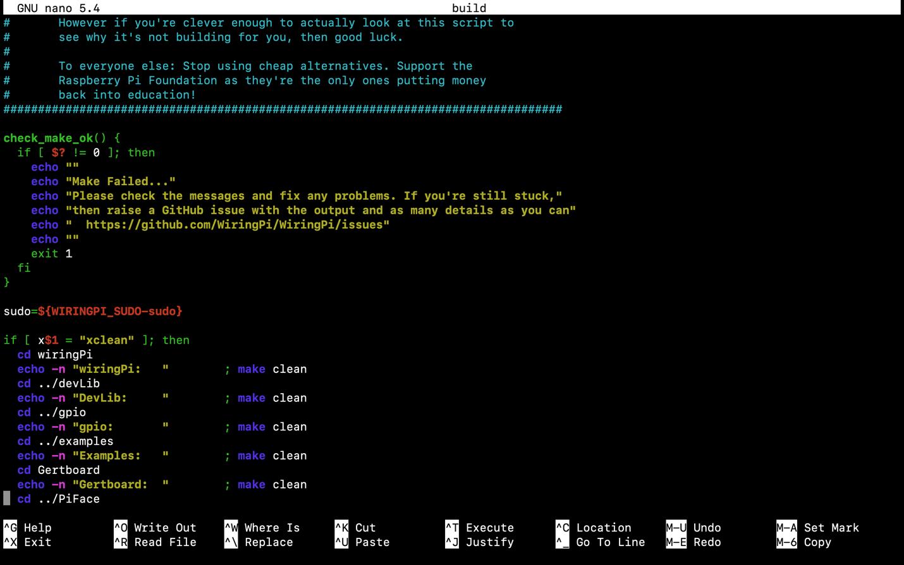

SourceCode - Makefile (wiringPi)

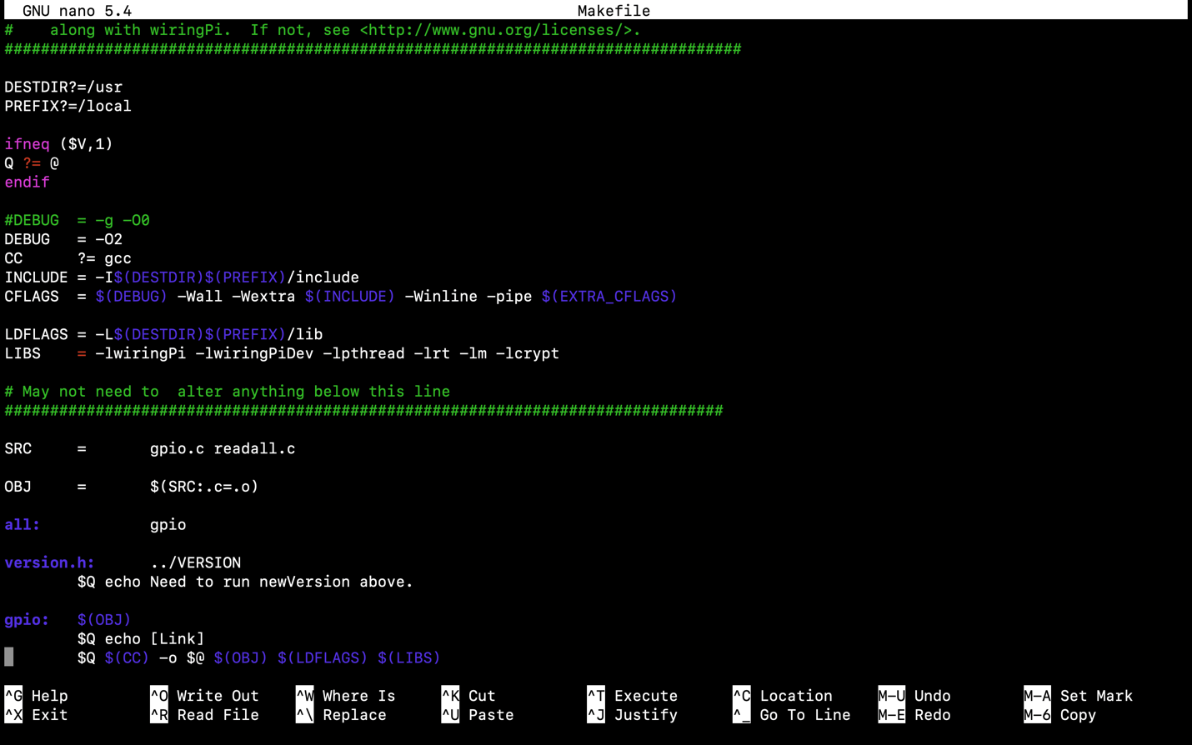

Output - build_sh (wiringpi)

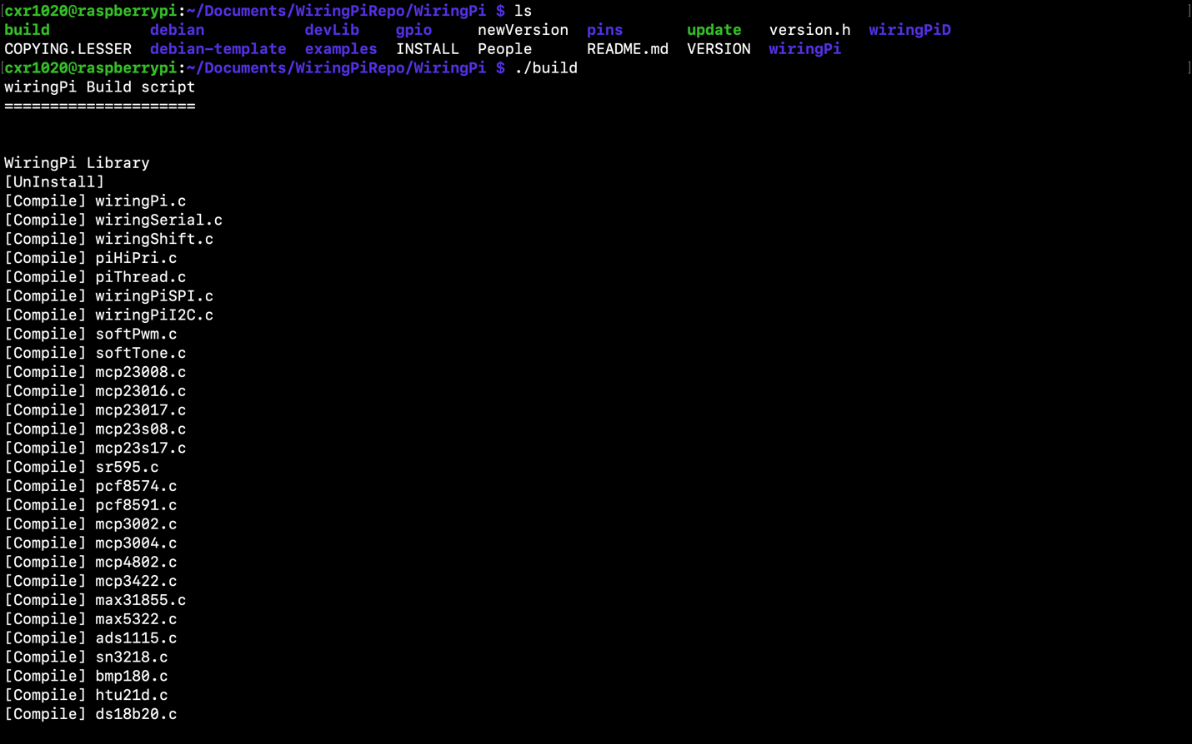

Command - gpio -v

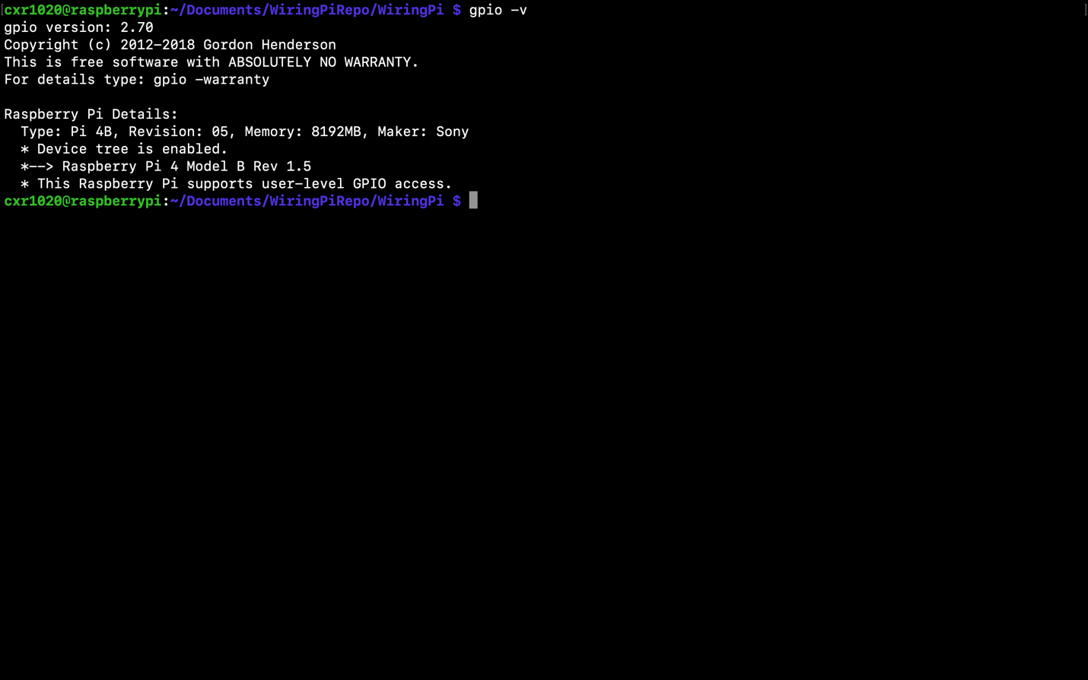

Command - gpio write 21 1

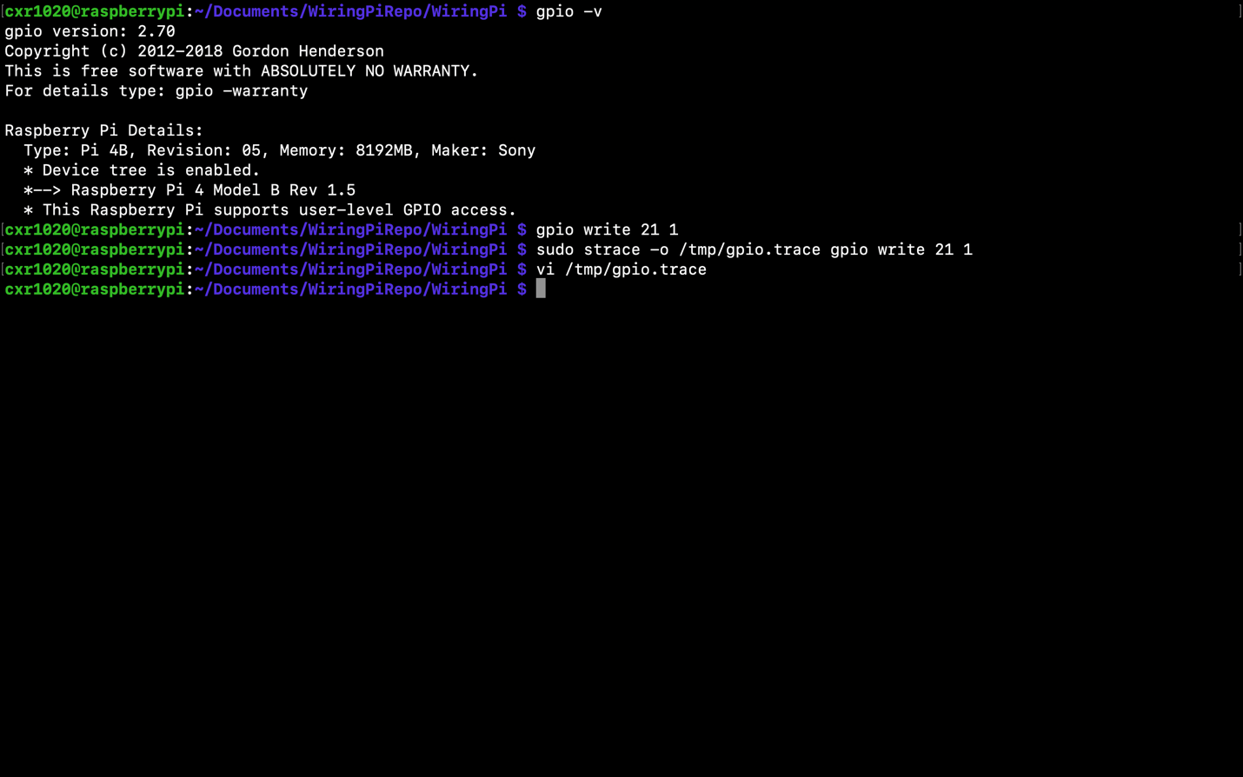

Command - sudo strace -o /tmp/gpio.trace gpio write 21 1

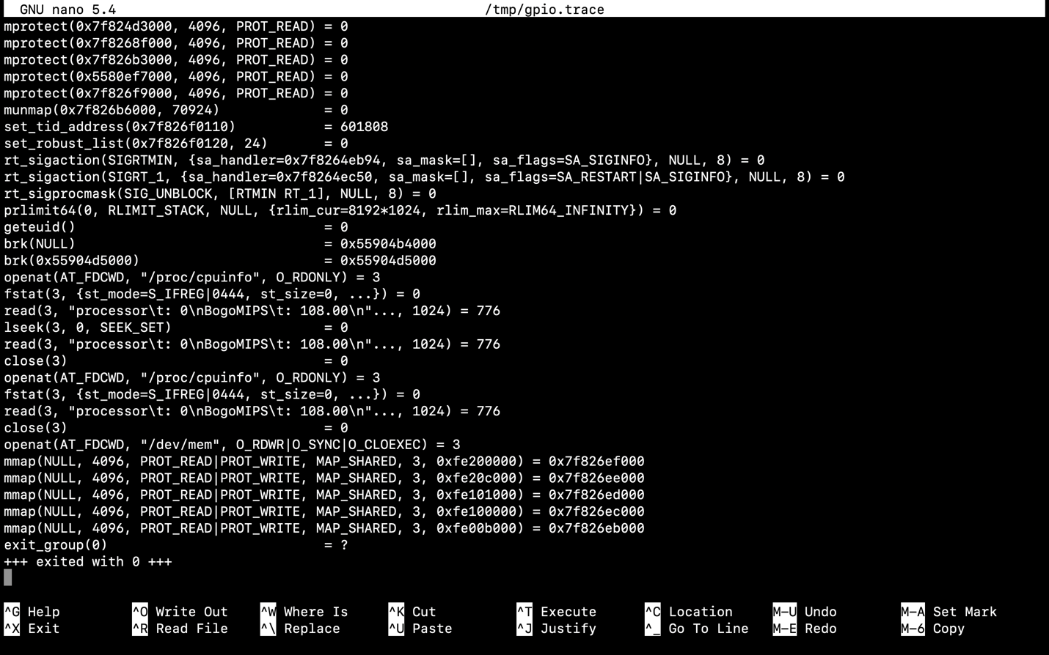

Command - ls /usr/local/include

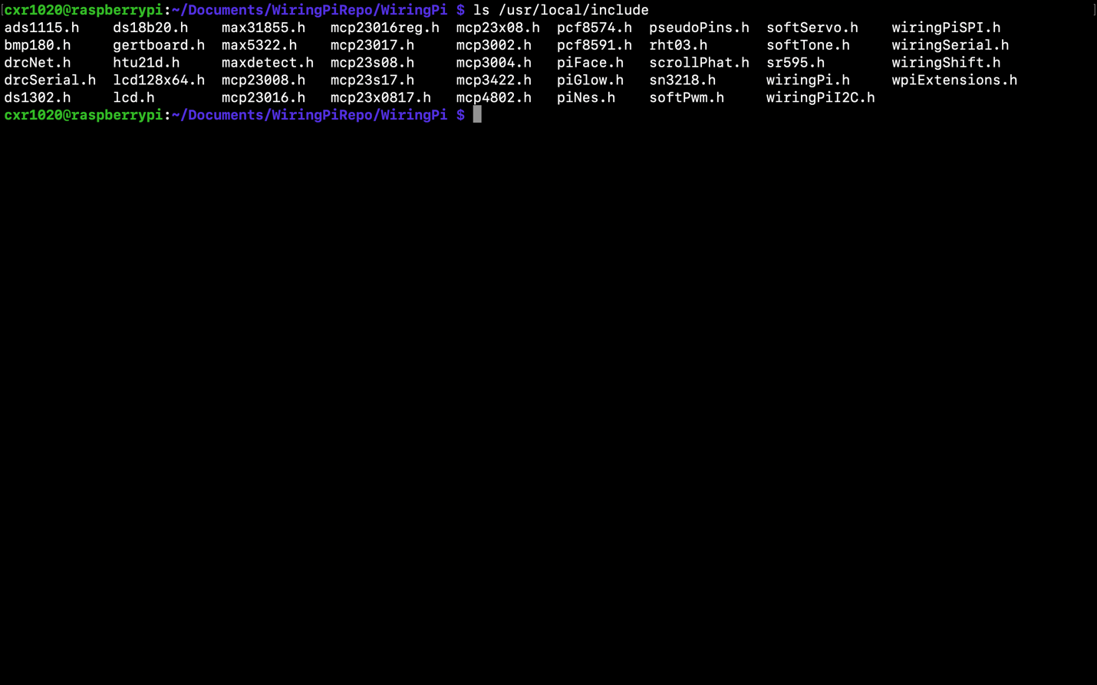

SourceCode - wiringpi_h 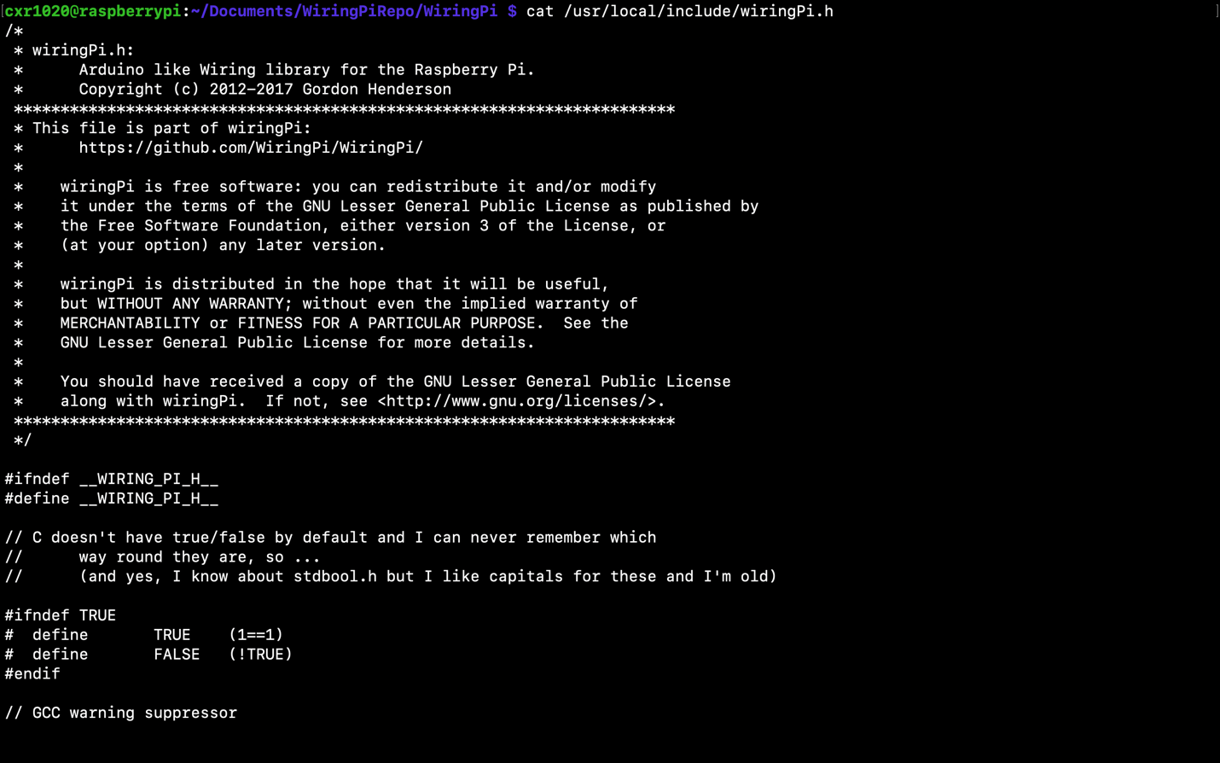

SourceCode - gpio-test_c

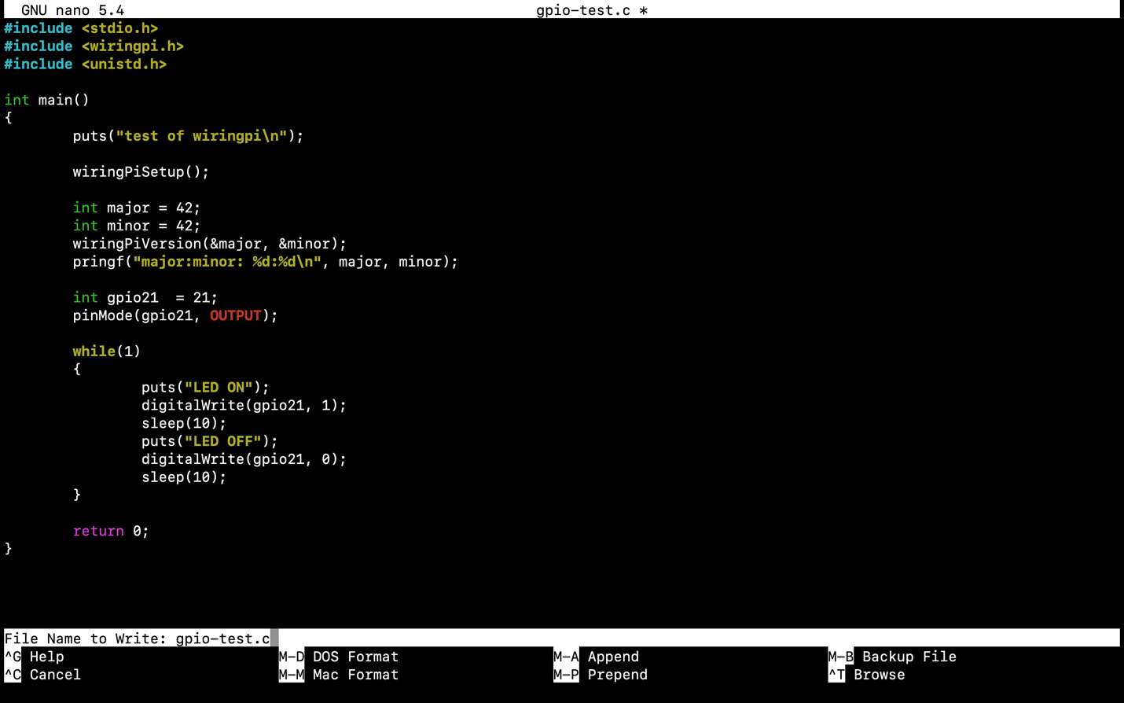

Output - gpio-test

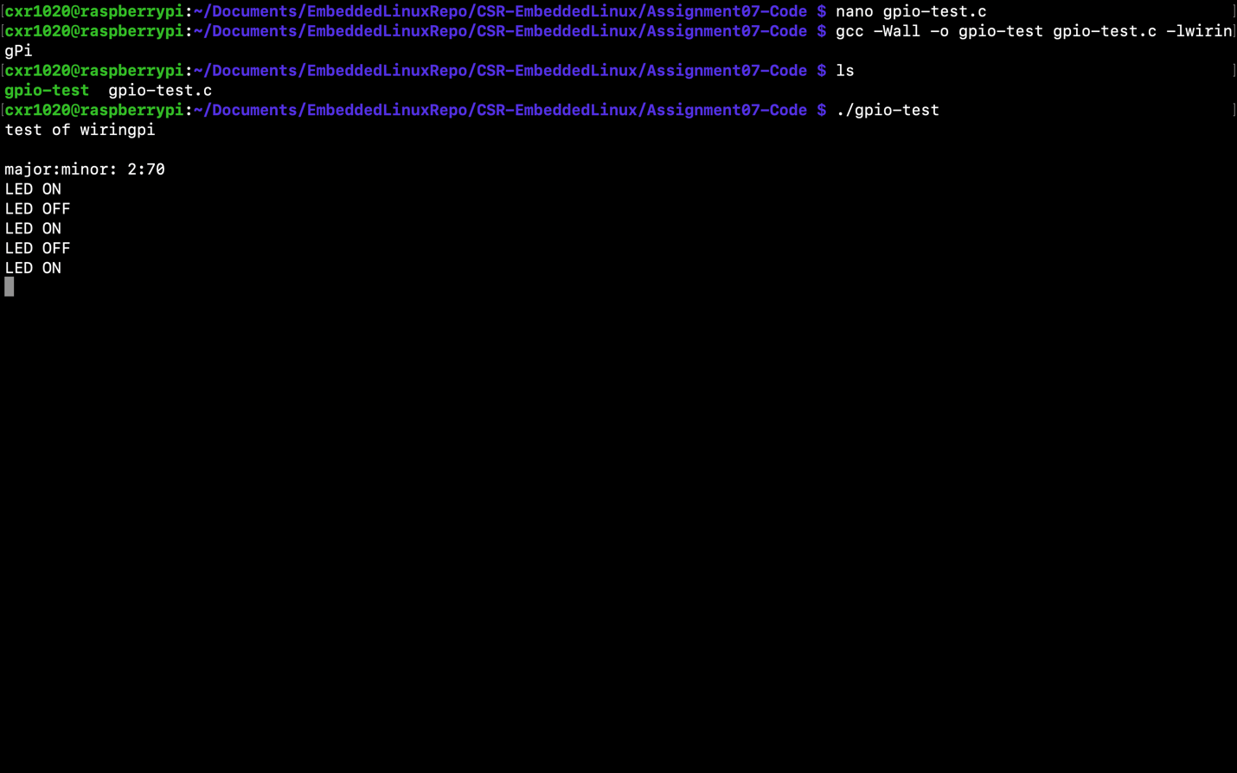

SourceCode - /boot/config_txt

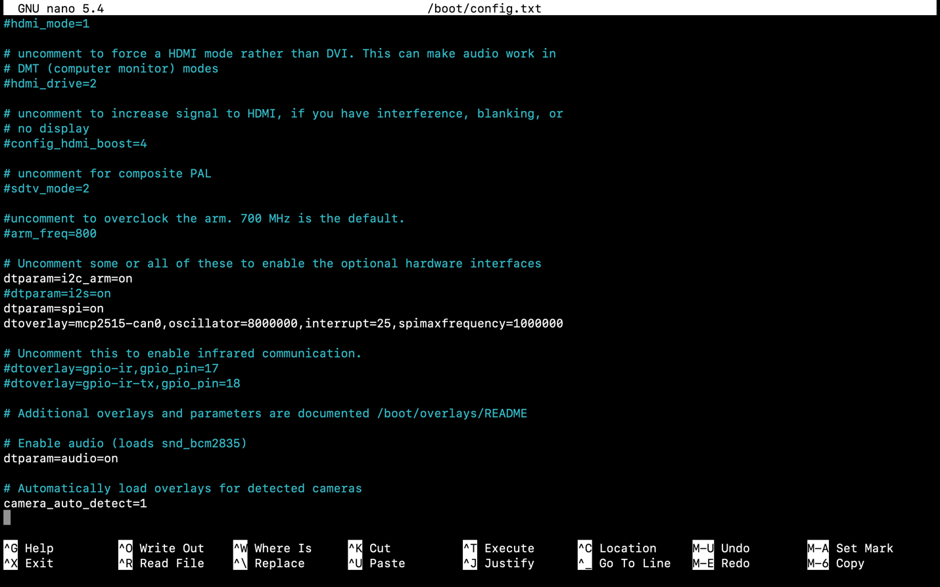

Output - dmesg | grep spi (before making hardware connections)

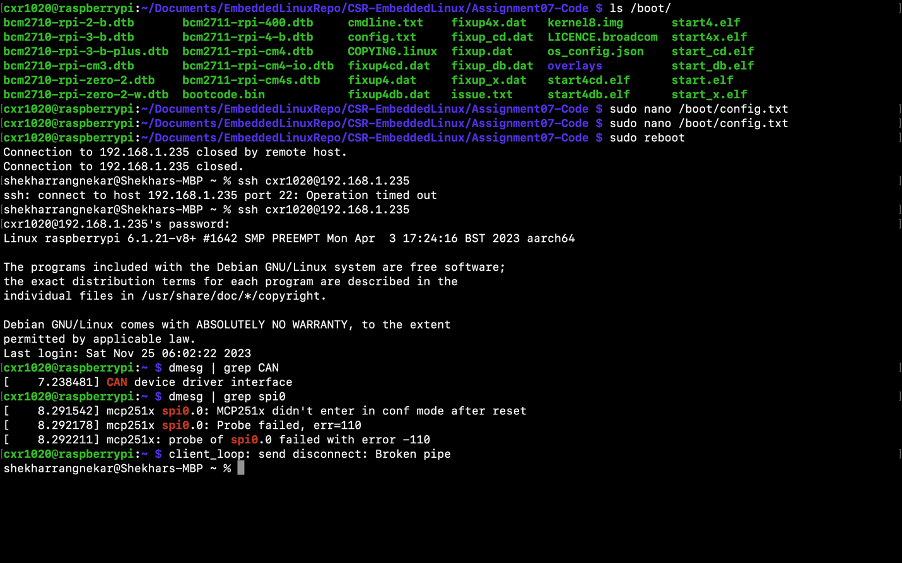

Output - dmesg | grep spi (after making connection)

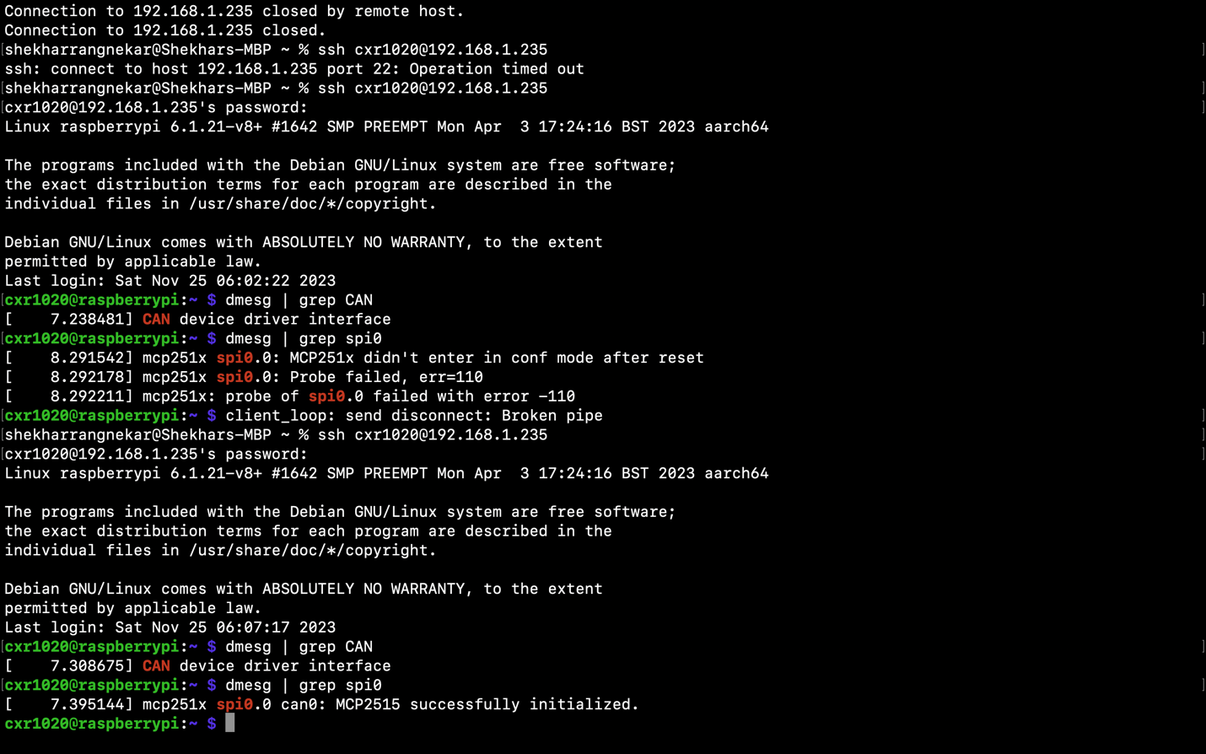

Command - ifconfig -a

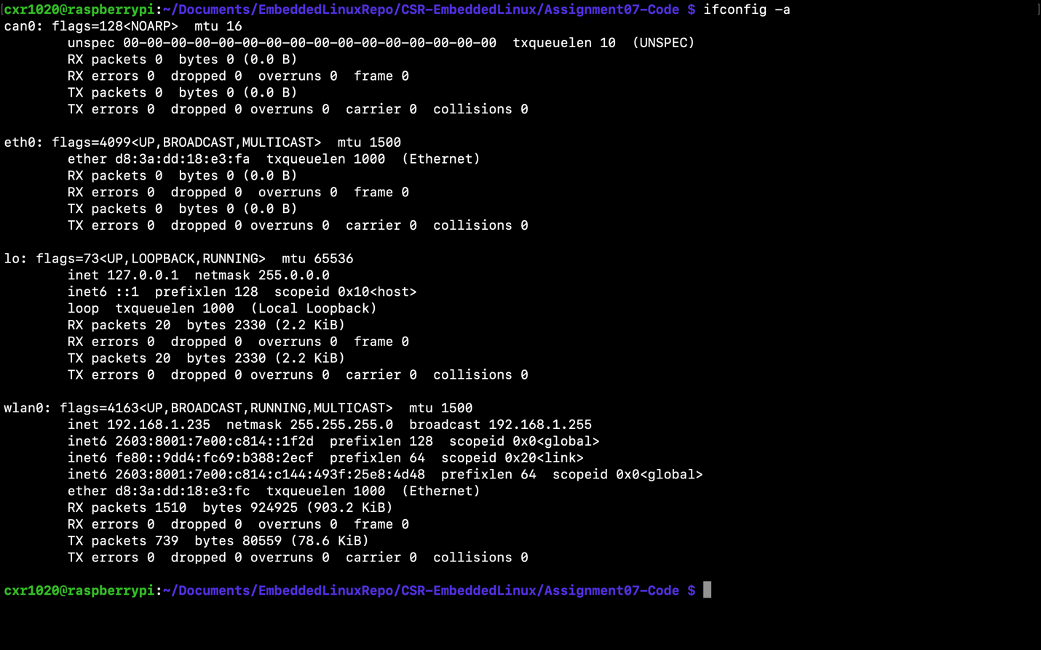

Command - ip link set can0 up type can bitrate 500000

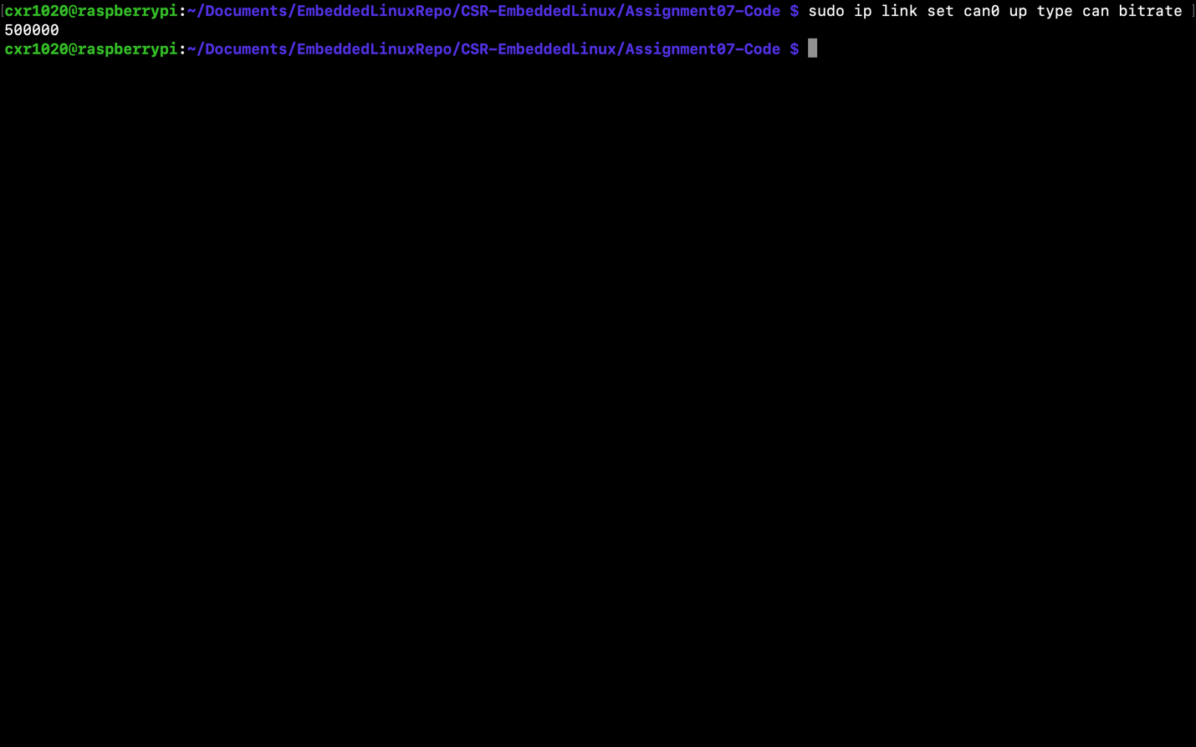

Command - sudo apt install can-utils

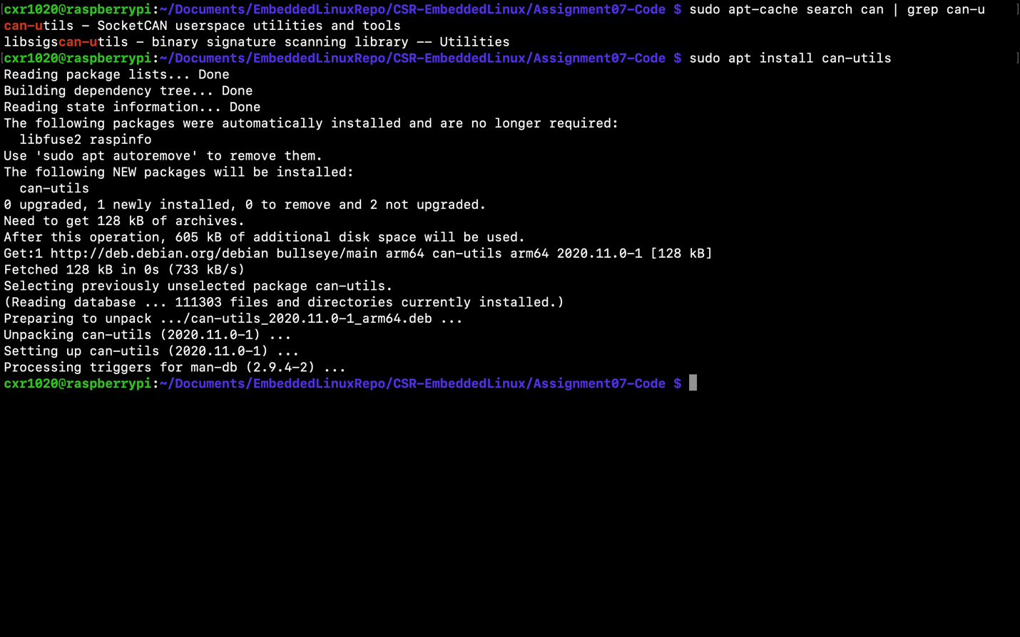

Command - dpkg -L can-utils

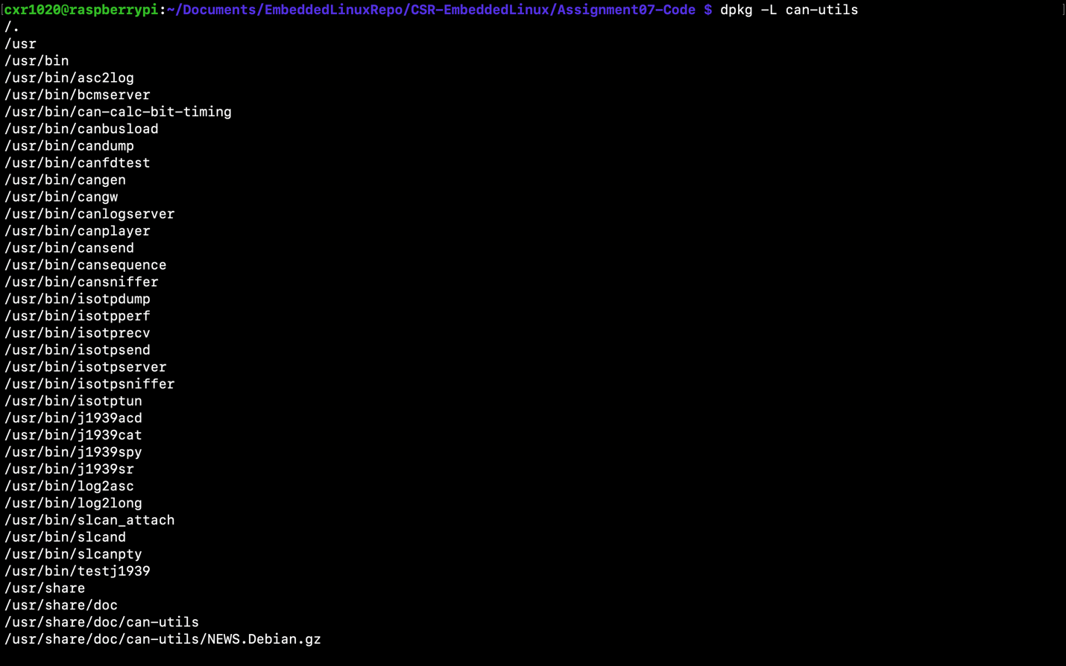

SourceCode - can_receive_c

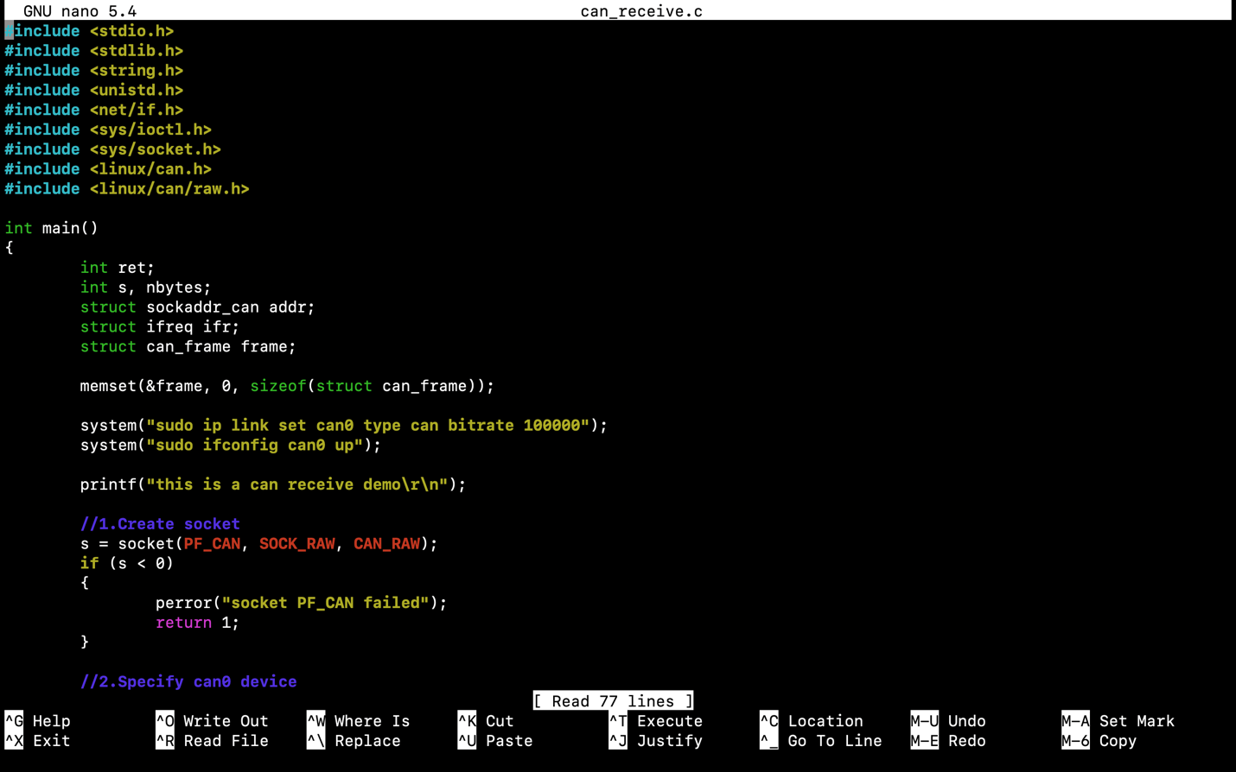

Output - can_receive

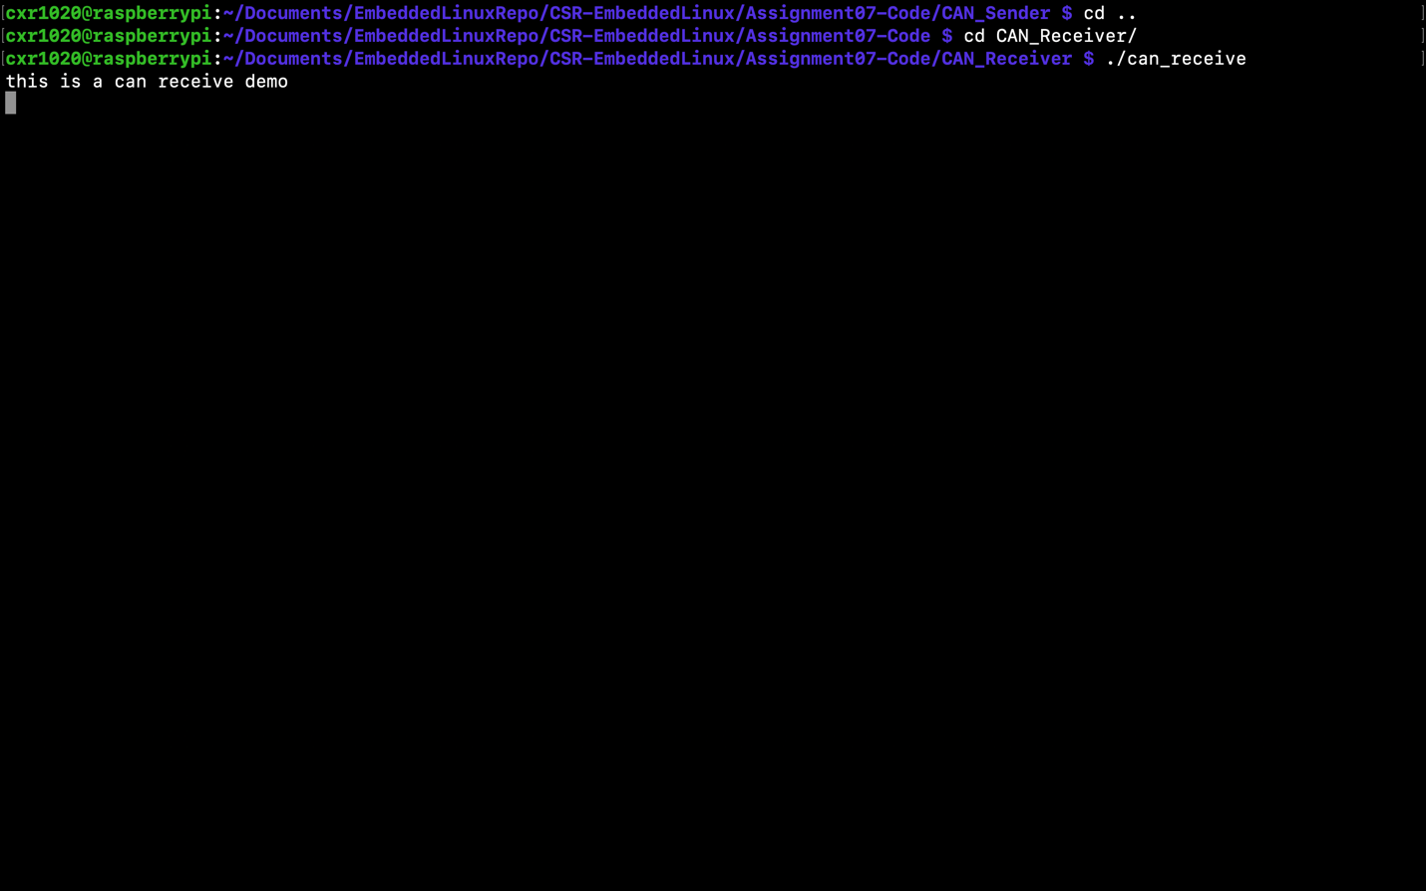

SourceCode - can_send_c

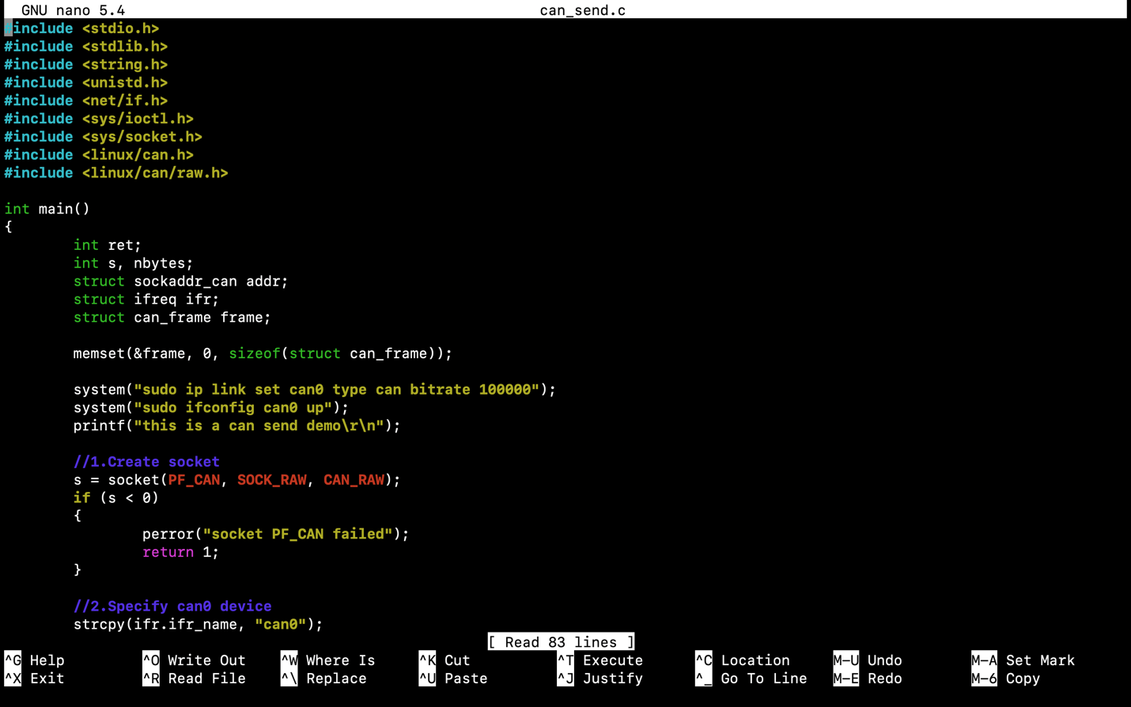

Output - can_send

